# **Overview**

This section should give a basic overview of the project and the team(s) behind it. An overview should include:

* **About your team** – A brief team information such as

**Members and their roles:**

Arysbay Dastan (barcode: 201672, mail: 201672@astanait.edu.kz) - Back-end Javascript and node.js programmer and helps to Laura with front-end Javascript

Khamitov Sanzhar (barcode: 201330, mail: 201330@astanait.edu.kz) – Documentation and helps to Laura with front-end Javascript

Akhmetkhan Alua (barcode: 201634 , mail: [201634@astanait.edu.kz](mailto:201634@astanait.edu.kz)) - HTML, CSS coding.

Akzhurek Askarbek (barcode: 201457 , mail: [201457@astanait.edu.kz](mailto:201457@astanait.edu.kz)) – HTML, CSS coding.

Tasheva Laura – Front-end developing

* + **Communication strategy** – We worked on videoconference all together, and solved problems one after another as it came in.
* **Motivation** – Why is the project needed?

In this project we use front-end Javascript and back-end java to upload the site to the server, and on the site itself, we can calculate all possible combinations of which of the players could score as many goals in theory.

* **High-level project scope** – Is it a redesign of a few pages, a complete website overhaul, or a brand-new website?

we create a website from scratch, except that we take some parts of the page from our other projects.

* **Target audience/market** – An overview of who this website is targeted at.

This site is aimed at people who need to calculate all the possible outcomes of a football match.

# **Project goals and team interests**

Briefly describe the goals of the project and what will your team gain from doing this project. This will give an idea of what you are trying to achieve, which will enable the most appropriate solutions.

Project goals

* Make a website for fans of football analytics

Team interests

* Understand Javascript in the frontend and backend
* Learn how to work with the server, that is, upload a site to the server.
* Improve team working skills by collaborating with different members of the group

# **Phases**

If this project is part of a bigger project, or there will be further phases following this project, it is useful to list these to give an indication of where this project fits into the bigger picture.

For example:

* Phase 1 – Basic football analytic with HTML (Currently)
* Phase 2 – Add styles to improve the appearance and thus draw wider audience
* Phase 3 - Write the front-end component of the site to javascript on
* Phase 4 – Write a backend part on node.js

# **Content structure**

**Site map**

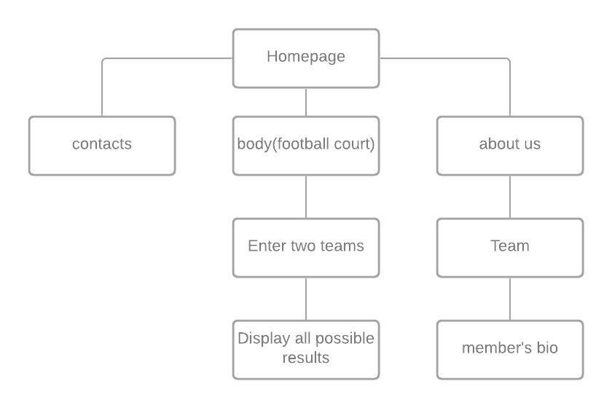

**Content types**

* About us (photos of our members and bio)
* Contacts
* Playing football match

**Design**

* Reference links: <https://getbootstrap.com/docs/5.0/components/navbar/>

<https://getbootstrap.com/docs/5.0/components/carousel/>

<https://getbootstrap.com/docs/5.0/examples/#custom-components>

* Image files: 2.jpg 3.jpg 4. 5.jpg 6.jpg 7.jpg

It is also important to provide a style guide and/or annotations for information such as:

* Colours: #fff, #CCFFCC, #f4f9f9, #1f1f1f;
* typography rules: “Times New Roman”, Times , serif.
* hover states:
* animations:
* grid systems: CSS Boostrap
* spacing: auto.

**Functionality**

The functionality of our site works so that when you enter names on our site, it outputs everyone to the console. Also when we can write the score, but the total score cannot exceed seven goals.

Then it displays all possible options on a list of those who, in theory, could have scored goals.

**Hosting**

We used node.js to upload the site to our own server. Now all of our pages can be displayed through our local server. Then we uploaded all the files to the github.

**Accessibility**

Making website accessible should be a priority. All content on our website is easily accessible and readable. Moreover, each section is designed so that it will be impossible to get confused in it. The general color does not interfere with the user, but disposes to itself. In addition, the site using the grid system makes it possible to use the site on all possible devices.

Top of Form

Bottom of Form

**Deadlines**

* Phase 1 – March 15, 20:00
* Phase 2 – March 16, 18:00

# **Summary**

As a result of the project, we have strengthened our knowledge of the Javascript language as well as the Nodk.js backend. We also learned how to make up a website on html and css in a short time.

On our site, you see how a user on this site can enter a team sheet (players) and also sees each individual player in the console. For example if first scores 4 goals output will be

the score list of team 1 can be (1 1 1 1), (1 1 2), (1 3), (2 2), (4) .

Then we will show the winner team.